**20.03.24 Report**

**SAW Sensors in Shear Bending**

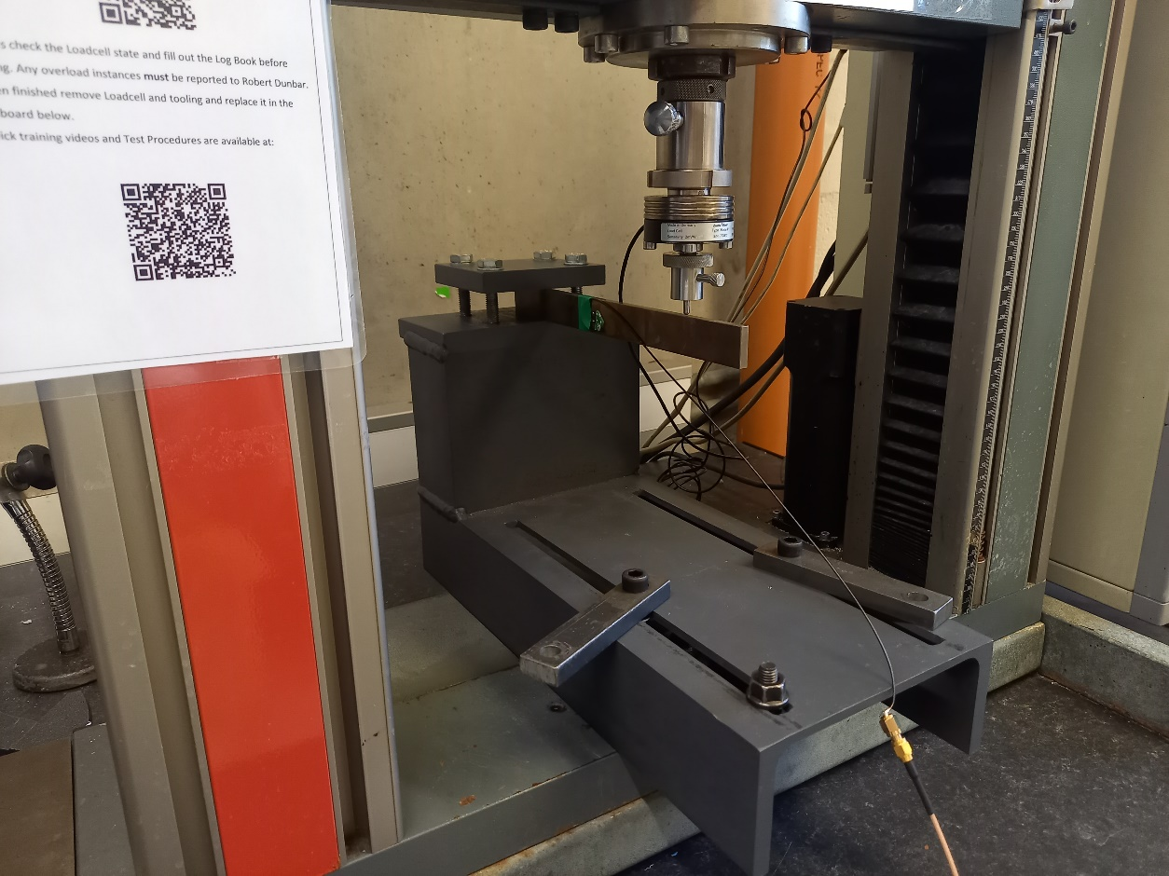

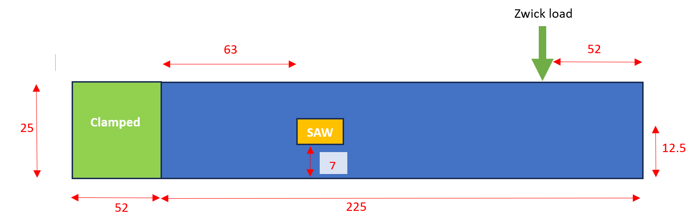**Figure 1.** Experimental setup

**Figure 2**. Beam dimensions (thickness = 6mm)

**Process:**

1. Loads applied in Zwick machine equipped with 200 (N? or kN?) load cell.
2. Preload of 50 N applied to beam, then load was zeroed at this value.
3. Load of 0, 10, 20, 30, 40, 50, 40, 30, 20, 10, 0 N then applied, holding for 10s at each load step.
4. Repeated x3 for each of the 4 bars (L, SM, N3 and N10)
5. Load data exported to .txt file on Zwick computer.

**Results**

Bar N3 Frequency (Test 1)

Bar N3 Hysteresis (Test 1)

Bar N10 Frequency (Test 1)

Bar N10 Hysteresis (Test 1)

Bar L Frequency (Test 1)

Bar L Hysteresis (Test 1)

Bar S Frequency (Test 1)

Bar SM Hysteresis (Test 1)

Sensitivity:

|  |  |  |  |
| --- | --- | --- | --- |
|  | **Sensitivity (Hz/g)** | |  |
| **Bar N3** | **M1** | **M2** | **T** |
| Test 1 | -0.6829 | 0.78763754 | 0.735591 |
| Test 2 | -0.69483 | 0.79965606 | 0.741371 |
| Test 3 | -0.68497 | 0.78703366 | 0.729461 |
| Average | -0.68757 | 0.79144242 | 0.735474 |

|  |  |  |  |  |
| --- | --- | --- | --- | --- |
|  | **Sensitivity (Hz/N)** | |  | |
| **Bar N3** | **M1** | **M2** | **T** | |
| Test 1 | -69.6127 | 80.28925 | 74.98375 | |
| Test 2 | -70.8284 | 81.5143791 | 75.57294 | |
| Test 3 | -69.824 | 80.2276923 | 74.35892 | |
| Average | -70.0884 | 80.6771071 | 74.97187 | |
|  | **Sensitivity (Hz/g)** | | |  |
| **Bar N10** | **M1** | **M2** | | **T** |
| Test 1 | -0.5320197 | 0.64481597 | | 0.499198 |
| Test 2 | -0.5701817 | 0.61782154 | | 0.476312 |
| Test 3 | -0.5835969 | 0.61878619 | | 0.473901 |
| Average | -0.5619328 | 0.62714123 | | 0.483137 |

|  |  |  |  |
| --- | --- | --- | --- |
|  | **Sensitivity (Hz/N)** | |  |
| **Bar N10** | **M1** | **M2** | **T** |
| Test 1 | -54.232381 | 65.7304762 | 50.88667 |
| Test 2 | -58.1225 | 62.97875 | 48.55375 |
| Test 3 | -59.49 | 63.0770833 | 48.30792 |
| Average | -57.281627 | 63.9287698 | 49.24944 |

|  |  |  |  |  |
| --- | --- | --- | --- | --- |
| **Sensitivity (Hz/g)** | | | | |
| **Bar L** | **M2** | **T** | **M3** | **M4** |
| Test 1 | -3.83515 | -1.91627011 | -0.79996 | 0.548063 |
| Test 2 | -3.61209 | -1.86815869 | -0.76859 | 0.565729 |
| Test 3 | -3.62478 | -1.8499058 | -0.76269 | 0.564061 |
| Average | -3.69067 | -1.87811153 | -0.77708 | 0.559284 |

|  |  |  |  |  |
| --- | --- | --- | --- | --- |
| **Sensitivity (Hz/N)** | | | | |
| **Bar L** | **M2** | **T** | **M3** | **M4** |
| Test 1 | -390.9426 | -195.3384416 | -81.54494 | 55.86779 |
| Test 2 | -368.20524 | -190.4341176 | -78.34791 | 57.66856 |
| Test 3 | -369.49872 | -188.5734759 | -77.74652 | 57.49861 |
| Average | -376.21552 | -191.4486784 | -79.21312 | 57.01165 |

|  |  |  |  |  |  |
| --- | --- | --- | --- | --- | --- |
|  | **Sensitivity (Hz/g)** | | |  | |
| **Bar SM** | **M2** | **T** | **M3** | | **M4** |
| Test 1 | -3.67089 | -2.29728128 | -0.64881 | | 1.119389 |
| Test 2 | -3.76906 | -2.23504033 | -0.63484 | | 1.127348 |
| Test 3 | -4.42912 | -2.29334491 | -0.6571 | | 1.144703 |
| Average | -3.95636 | -2.27522217 | -0.64691 | | 1.13048 |

|  |  |  |  |  |  |
| --- | --- | --- | --- | --- | --- |
|  | **Sensitivity (Hz/N)** | | |  | |
| **Bar SM** | **M2** | **T** | **M3** | | **M4** |
| Test 1 | -374.199 | -234.1775 | -66.1374 | | 114.1069 |
| Test 2 | -384.206 | -227.832857 | -64.7137 | | 114.9183 |
| Test 3 | -451.49 | -233.776239 | -66.9822 | | 116.6874 |
| Average | -403.298 | -231.928865 | -65.9444 | | 115.2375 |

N3 and N10 far less sensitive than SM and L